Operating Systems Lab – 2

Dipesh Singh – 190905520

Question – 1 : Write a C program to emulate the ls – l UNIX command that prints all the files in a current directory and lists access privileges, etc. Do not simply exec ls -l from the program.

Source Code : ls.c

#include <sys/types.h>
#include <sys/stat.h>
#include <unistd.h>
#include <stdio.h>
#include <stdlib.h>
#include <dirent.h>
#include <time.h>
#include <string.h>
#include <pwd.h>
#include <grp.h>
#include <time.h>
#include <locale.h>
#include <langinfo.h>
#include <stdint.h>
char const *sperm(__mode_t mode)
{
static char local_buff[16] = {0};
int i = 0;
// user permissions
if ((mode & S_IRUSR) == S_IRUSR)
local_buff[i] = 'r';
else
local_buff[i] = '-';
i++;
if ((mode & S_IWUSR) == S_IWUSR)
local_buff[i] = 'w';
else
local_buff[i] = '-';
i++;
if ((mode & S_IXUSR) == S_IXUSR)
local_buff[i] = 'x';
else
local_buff[i] = '-';
i++;
// group permissions
if ((mode & S_IRGRP) == S_IRGRP)
local_buff[i] = 'r';
else
local_buff[i] = '-';
i++;
if ((mode & S_IWGRP) == S_IWGRP)
local_buff[i] = 'w';
else
local_buff[i] = '-';
i++;
if ((mode & S_IXGRP) == S_IXGRP)
local_buff[i] = 'x';
else
local_buff[i] = '-';
i++;
// other permissions
if ((mode & S_IROTH) == S_IROTH)
local_buff[i] = 'r';
else
local_buff[i] = '-';
i++;
if ((mode & S_IWOTH) == S_IWOTH)
local_buff[i] = 'w';
else
local_buff[i] = '-';
i++;
if ((mode & S_IXOTH) == S_IXOTH)
local_buff[i] = 'x';
else
local_buff[i] = '-';
return local_buff;
}
int main(int argc, char *argv[])
{
DIR *mydir;
struct dirent *myfile;
struct stat mystat;
if(argc == 1) mydir = opendir(".");
else
mydir = opendir(argv[1]);
while ((myfile = readdir(mydir)) != NULL)
{
bzero(&mystat, sizeof(mystat));
stat(myfile->d_name, &mystat);
printf("%10.10s", sperm(mystat.st_mode));
printf("\t%d", mystat.st_uid);
printf("\t%ld\t", mystat.st_size);
printf("%s\t", ctime(&mystat.st_mtime));
printf("%s\n", myfile->d_name);
}
closedir(mydir);
}

Output :

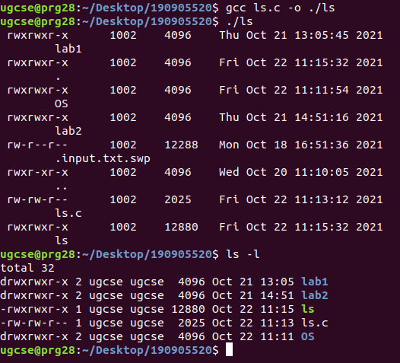
Question 2 : Write a program that will list all files in a current directory and all files in subsequent subdirectories.

Source Code : dir.c

#include <unistd.h>
#include <sys/stat.h>
#include <sys/types.h>
#include <stdio.h>
#include <stdlib.h>
#include <dirent.h>
#include <string.h>

void execFunc(char * dir, int depth){
struct dirent * myfile;
struct stat mystat;
DIR * mydir = opendir(dir);
chdir(dir);
while((myfile = readdir(mydir))!=NULL){
bzero(&mystat, sizeof(mystat));
stat(myfile->d_name, &mystat);
for(int i = 0; i<depth; i++) printf(" ");
printf("%s", myfile->d_name) ;
if(S_ISDIR(mystat.st_mode)) printf("/");
printf("\n");
if(S_ISDIR(mystat.st_mode) && strcmp(myfile->d_name, ".")!=0 && strcmp(myfile->d_name, "..")!=0){
execFunc(myfile->d_name, depth+1);
}

}
chdir("..");
closedir(mydir);
}

int main(){
execFunc(".", 0);
return 0;
}

Output :
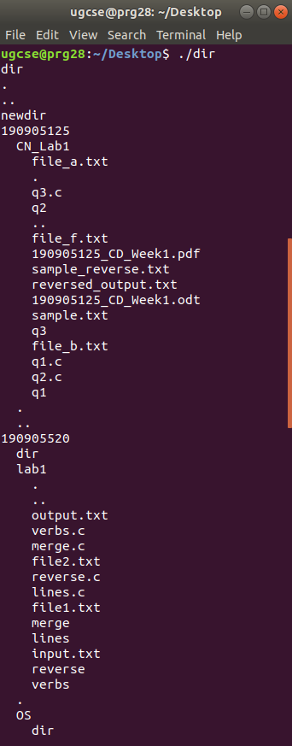
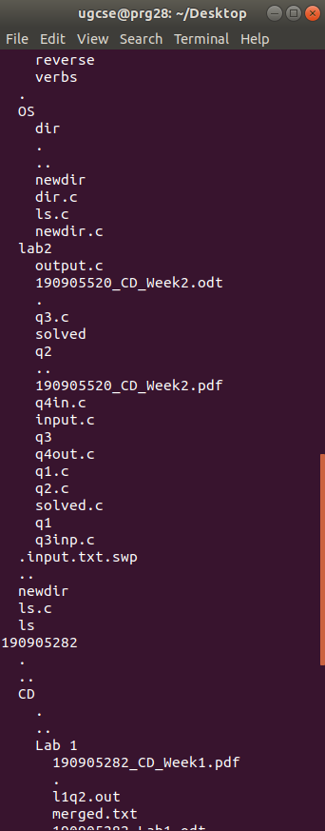

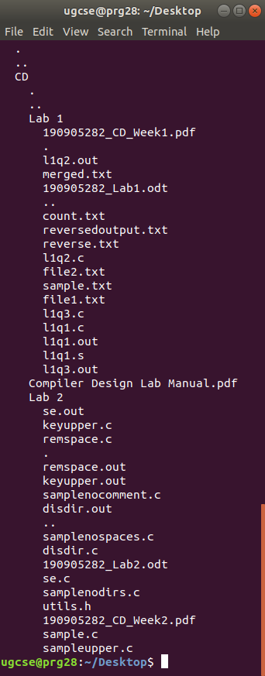
Question 3 : How do you list all installed programs in Linux?

Source Code :

$ dpkg -l

Output :

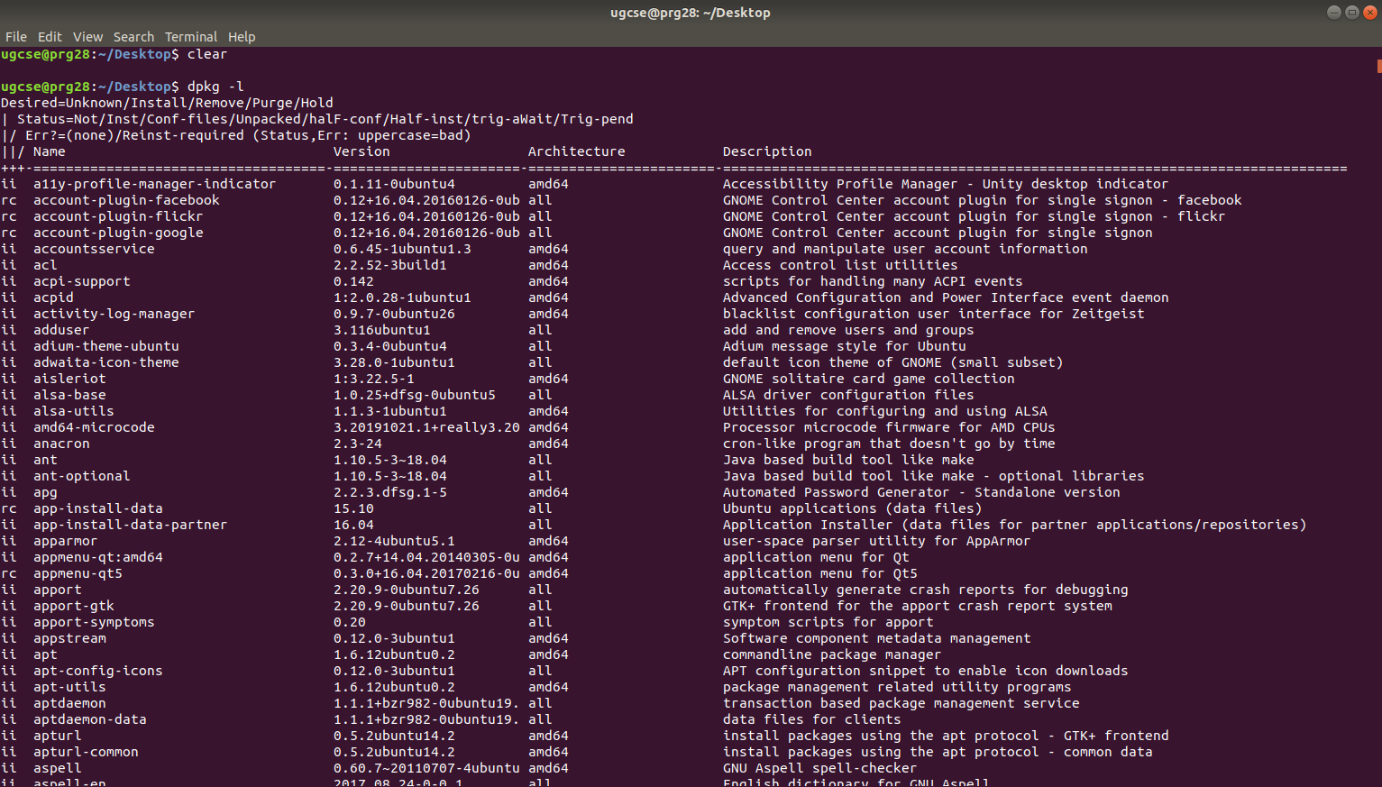
Question 4 : How do you find out what RPM Packages are installed on Linux?

Remarks : RPM is not installed on Ubuntu by default.

Source Code :

$ rpm -qa

Output :

